Lab 20. Shift register

Introduction:

Where do we use it?

**Hard disk drive’s interface**

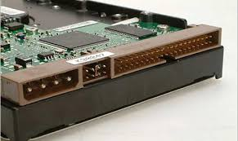

IDE interface

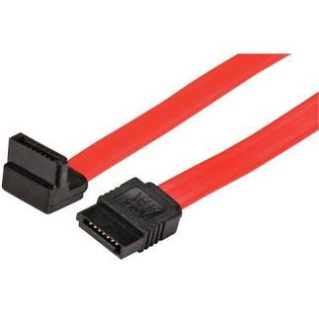

SATA interface

Shift register is used to read data to CPU from serial interface.

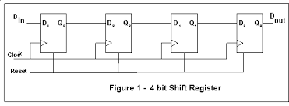

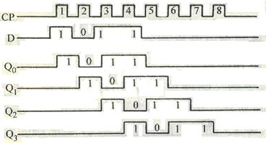

1. **Be familiar with D flip flop.**

Simulink D flip flop, Boolean conversion, constant, pulse wave generators, scope

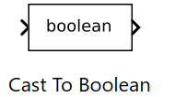

Configuration:

1. constant=1.
2. Pulse wave generator (input signal):

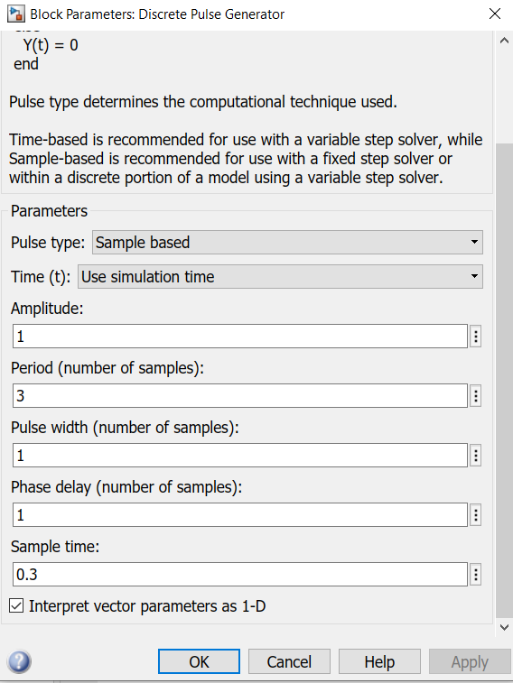

1. Pulse wave generator (clock signal):

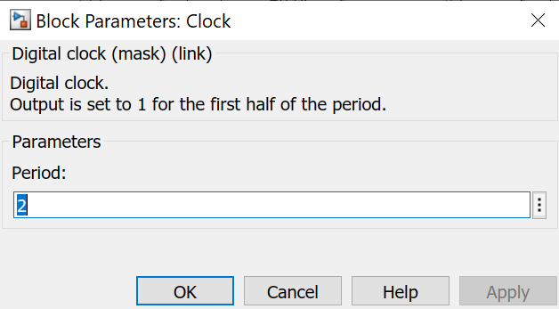

1. Scope: observe clock signal, input signal and output signal.

Today’s lab:

Add three more D flip flops to workspace and make the connections. Each flip flop is controlled by the same clock signal and enable input signal (!CLR). In the scope, observe the clock signal, input signal, 4 output signals.